SD11359823 &SD11338968 Migration Instructions

Author: Lakshmi Supriya

Creation Date: April 28, 2016

Last update Date: April 28, 2016

Document Ref: BI-ETL-0001

Version: 1.0

1. **Title, Subject, Last Updated Date, Reference Number**, **and** **Version** are marked by a Word Bookmark so that they can be easily reproduced in the header and footer of documents. When you change any of these values, be careful not to accidentally delete the bookmark. **You can make bookmarks visible by selecting the Office Button>Word Options>Advanced> and checking the Show bookmarks option in the Show document content region.**

**Approvals:**

|  |  |
| --- | --- |
| <Approver 1> | Vinay Pachika |

1. To add additional approval lines, press [Tab] from the last cell in the table above.
2. You can delete any elements of this cover page that you do not need for your document.

|  |  |
| --- | --- |
| <Approver 2> | Viswam Nair |

# Document Control

## Change Record

3

| Date | Author | Version | Change Reference |
| --- | --- | --- | --- |
| 28-April-16 | Lakshmi Supriya | 1.0 | For PRODUCTION Issue |
|  |  |  |  |
|  |  |  |  |

## Reviewers

| Name | Position |
| --- | --- |
| Abhishek Chattopadhyay | Technical Lead (OBIEE & ODI) |
|  |  |
|  |  |
|  |  |

Contents

1 Document Control 2

1.1 Change Record 2

1.2 Reviewers 2

2 Installation Instructions for Code Migration 4

2.1 Pre-Migration Steps 4

2.2 Migration Steps for bug fixes of Custom Packages (Defect # IM8022701) 4

2.2.1 Transfer table script to Target SVN repository 4

2.2.2 Transfer ODI packages to Target SVN Repository 5

2.2.3 Import ODI packages into Target instance 5

2.2.4 ODI Model for Custom Fact 9

2.2.5 Re-generate the Custom ODI Packages 10

2.2.6 Re-Generate Load Plan in the Target instance 10

2.3 Verification Checklist 12

2.3.1 New Components – Sanity Check 12

3 Open and Closed Issues 15

3.1 Open Issues 15

3.2 Closed Issues 15

# Installation Instructions for Code Migration

|  |  |
| --- | --- |
| **Source Environment Name:** Test | **Machine:** TCGIT3 |

|  |  |
| --- | --- |
| **Target Environment Name**: UAT | **Machine:** TCGI13 |

## Pre-Migration Steps

* **Take complete database backup of the target instance.**
* Login to the ODI studio and apply the <Target> Environment Repository Connection Information and ensure you are able to connect to the Repository with the given user credentials
* Export the ODI Topology of the Target Instance for the backup for the very first time migration

Goto> ODI Studio client> Topology Navigator > click on Connect Navigator > Export > Select Export the Topology> Save it on your local (backup)

* Able to access the ODI Enterprise Configuration manager application with the user credentials
* Ensure the credentials are ready with the Source database and Target Datawarehouse environment details being migrated
* Take the ODIREPO schema database backup of the target instance if the load is executed for the very first time in the target instance.
* Drop all the temp tables in the Target instance by running the below query

SELECT Table_Name, Num_Rows

FROM All_Tables

WHERE (Table_Name LIKE 'C$%'

        OR Table_Name LIKE 'I$%')

      AND Num_Rows > 0

ORDER BY Num_Rows DESC;

## Migration Steps for bug fixes of Custom Packages (Defect # SD11359823 & SD11338968)

### Transfer table script to Target SVN repository (DBA)

**NOTE:** Ensure the SVN update is complete before downloading the files from the SVN

* Copy below table creation scripts from Source SVN repository to target repository

SVN Base Path: http://subversion.sys.cigna.com/svn/ORACLE_BI_REPO

Source Location: <http://subversion.sys.cigna.com/svn/ORACLE_BI_REPO\CRP2-TS_MAIN\DBScripts\Tables\Prod_Release>

Target Location : <http://subversion.sys.cigna.com/svn/ORACLE_BI_REPO/UAT_MAIN/DBScripts>/Tables

Below are the DB Scripts

| Script # | Version # | File Name |
| --- | --- | --- |
| 1. | 966 | Alter_WC_NONFAH_PREALL_EXP_FS.sql |
| 2 | 966 | Alter_WC_SL_PREALLOC_FS.sql |

* Do SVN Commit

### Transfer EBS script (DBA)

Below are the Views are changed in EBS.

**XXC_XLA_AE_WEBADI_LIN_V, XXC_NONFAH_PREALLOC_V and**

**XXC_XLA_SL_DISTN_LINK_V**

### Transfer ODI packages to Target SVN Repository

* Copy below ODI objects from Source SVN repository to target repository

SVN Base Path: <http://subversion.sys.cigna.com/svn/ORACLE_BI_REPO>

Source Location: [http://subversion.sys.cigna.com/svn/ORACLE_BI_REPO/CRP2-TS_MAIN/ODI/Custom/Prod Releases/](http://subversion.sys.cigna.com/svn/ORACLE_BI_REPO/CRP2-TS_MAIN/ODI/Custom/Prod%20Releases/)

Target Location : <http://subversion.sys.cigna.com/svn/ORACLE_BI_REPO/UAT_MAIN/ODI/Custom>

| Script # | Version # | File Name |
| --- | --- | --- |
|  | 969 | SDE_WC_P1_Stage_PreallocExpenseFact |
|  | 969 | SDE_WC_P2_Stage_NONFAHPreallocExpenseFact |
|  | 969 | SDE_WC_P3_Stage_SubLedgerPrealloacExpenseFact |
|  | 969 | SIL_WC_P2_NONFAHPreallocExpenseFact |
|  | 969 | SIL_WC_P3_SubLedgerPrealloacExpenseFact |

* Do SVN Commit

### Import ODI packages into Target instance

* Log into ODI Studio with a user as bi apps administrator.
* Import ODI objects into the target instance as shown in the screen shot below.
* Desginer Navigation: Go to Projects 🡪 click on Connect Navigator --> Select Import

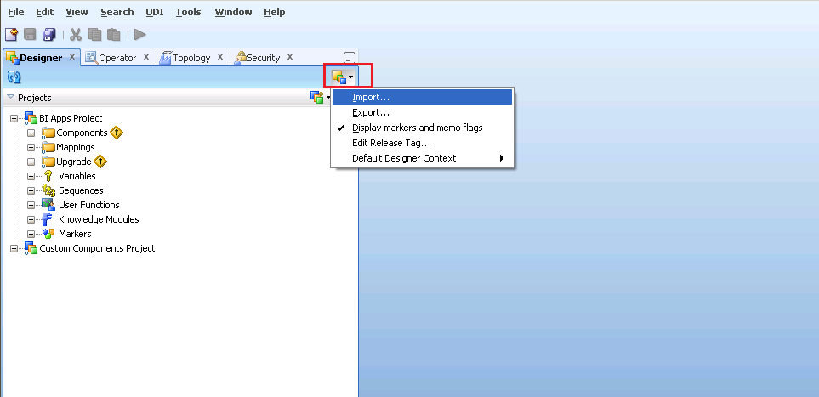

* Select the option Smart Import and then clieck Ok

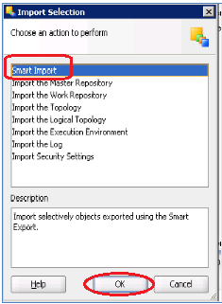

* Browse and Select the ZIP files downloaded from SVN listed below: (Only one file can be selected at a time)



* **Note**: At the Import Actions step, Goto Topology Section--> Select each component beneath it and mark the Action = Ignore from the dropdown values (this applies for only Topology)

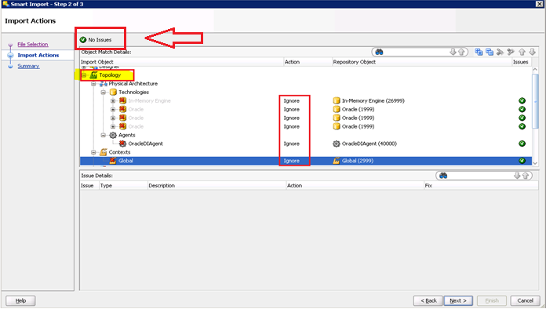

* Check if any errrors on the top, if No Issues displayed then Click Next
* You can see the new added objects and then you Save the details and Close the window

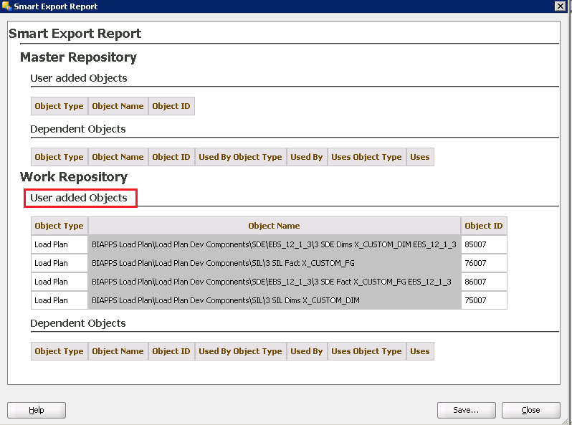

* Complete importing every file listed below by following the above steps sequence. Save the log and send to dev team if errors are encountered.

| Script # | File Name |
| --- | --- |
|  | SDE_WC_P1_Stage_PreallocExpenseFact |
|  | SDE_WC_P2_Stage_NONFAHPreallocExpenseFact |
|  | SDE_WC_P3_Stage_SubLedgerPrealloacExpenseFact |
|  | SIL_WC_P2_NONFAHPreallocExpenseFact |
|  | SIL_WC_P3_SubLedgerPrealloacExpenseFact |

**NOTE:** You can ignore/overwrite the OOB table(W_%) errors shown while importing any of the above packages

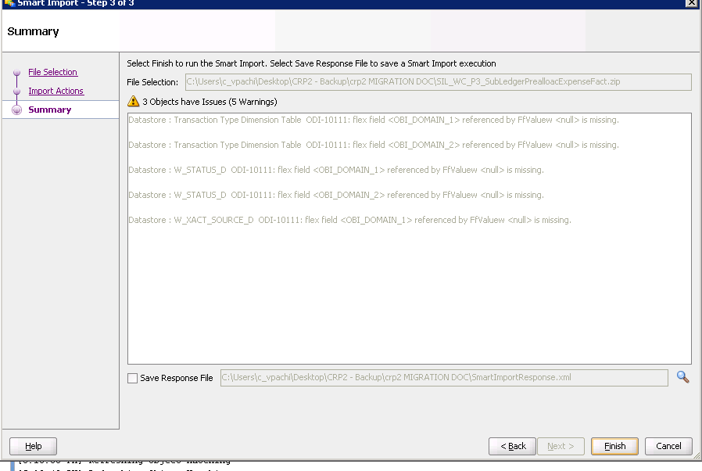

### ODI Model for Custom Fact

* + - Login to target instance as admin

Designer > Models > Oracle BI Applications > Oracle BI Applications > Fact > WC_PREALLOC_EXP_F > Columns > Hit Reverse Engineering option > Save the changes

Verify the EXPENSE_GROUP_DESC is removed .Otherwise remove manually.

* + - Verify that the partition keys were imported as shown below. Otherwise configure manually

### Re-generate the Custom ODI Packages

* Regenerate the below Custom package scenarios

Desginer : Goto Projects > BI Apps Project > Mappings > Custom_SDE_Adaptor

| Script # | File Name |
| --- | --- |
|  | SDE_WC_P1_Stage_PreallocExpenseFact |
|  | SDE_WC_P2_Stage_NONFAHPreallocExpenseFact |
|  | SDE_WC_P3_Stage_SubLedgerPrealloacExpenseFact |
|  | SIL_WC_P2_NONFAHPreallocExpenseFact |
|  | SIL_WC_P3_SubLedgerPrealloacExpenseFact |

### Re-Generate Load Plan in the Target instance

* Login to BI Configuration Manager as bi apps administrator. Pick work repository option

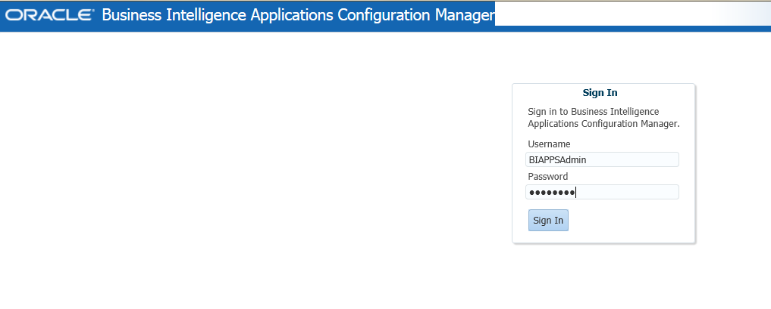

* Navigate to Manage Load Plans

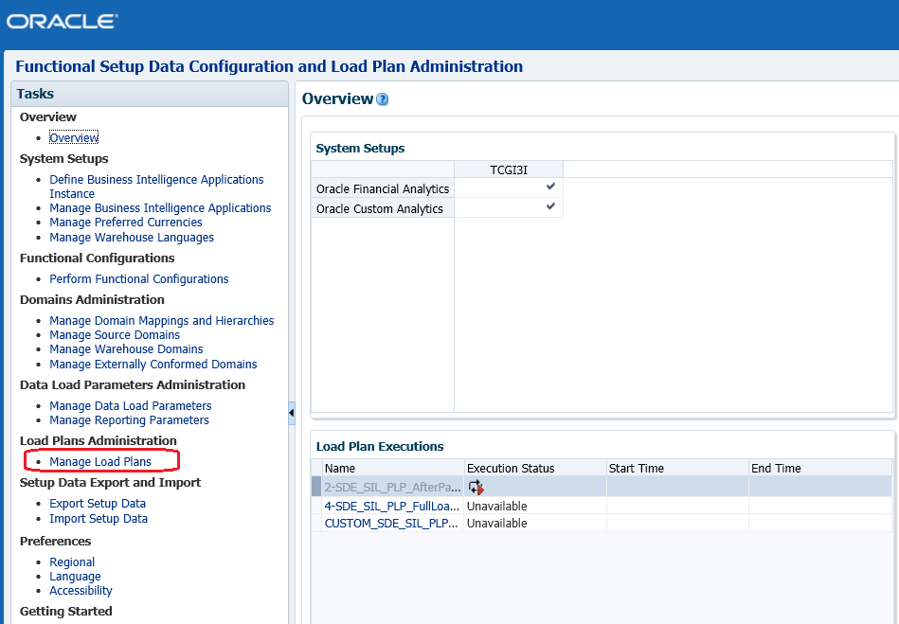

* Select the (Custom + OOB) Load Plan and then hit the Generate Icon.
* Once the generation is successful the status will show as GREEN
* Similarly select only Custom Load plan and then hit the Generate Icon.

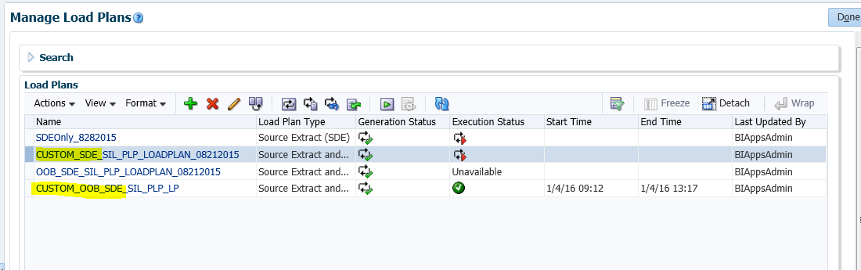

* Both the Load plans should show the status as GREEN and without any warnings.

## Verification Checklist

1. Include a subset of test steps that will confirm that the customization has been installed properly.

Verify that the deployment has been completed successfully by following these steps:

### New Components – Sanity Check

* All the components in the ETL_FAH 0006 should be displayed, please do the following high level components in the ODI Studio, under the CUSTOM_SDE_Adaptor and CUSTOM_SILOS

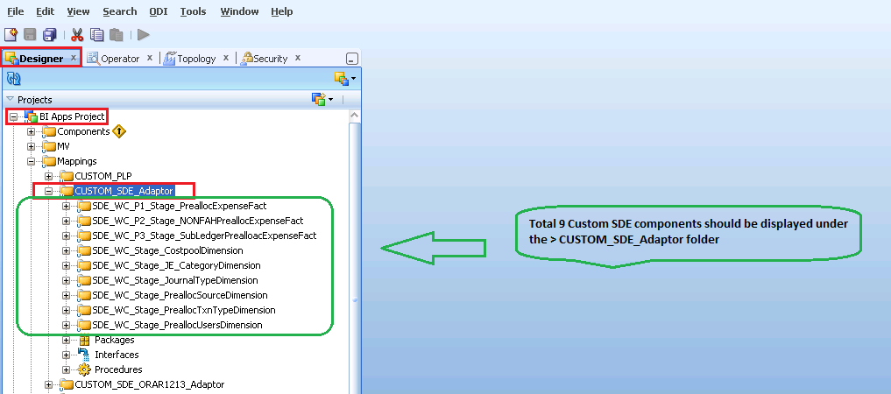

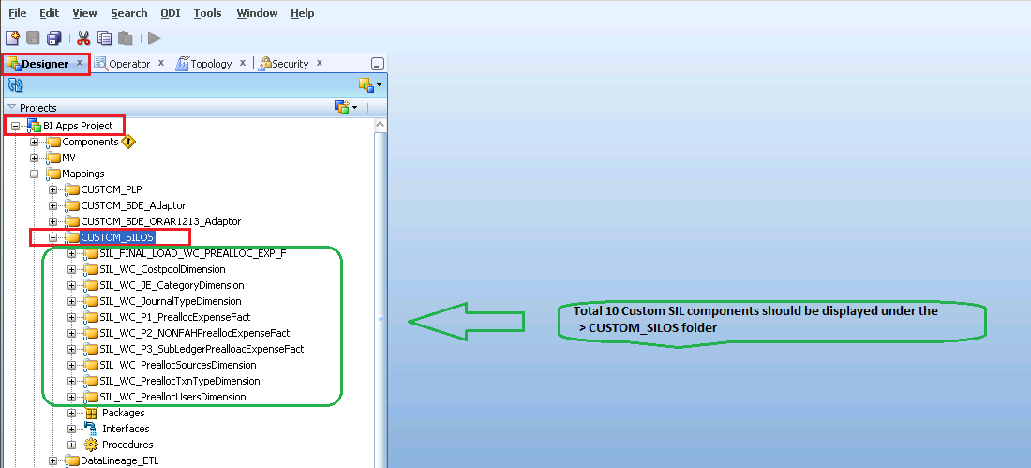

* New Generated load plan should be visible under the ‘Generated Load Plans’ and all the Custom folders should be visible when you drill down the hierarchy

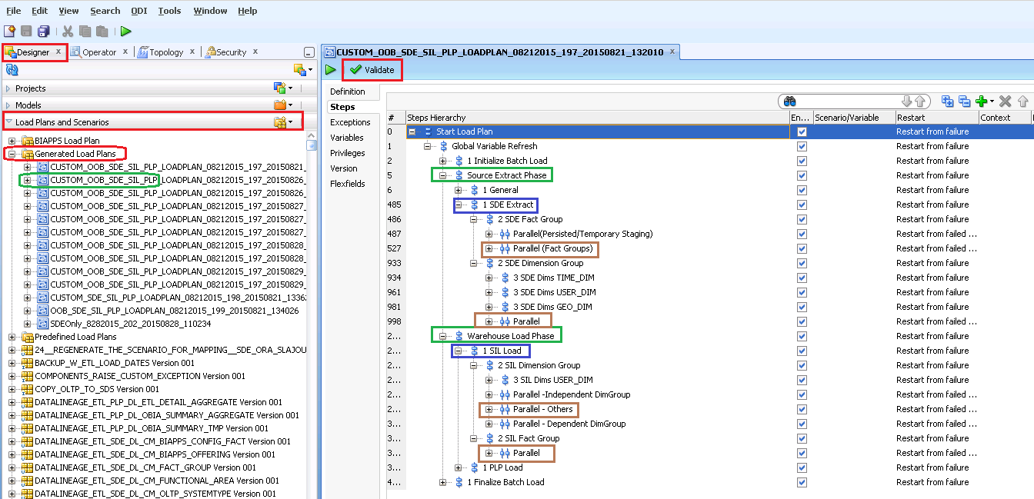

**NOTE:**

1. Please make sure Default option is checked for the BIACM_IO, DW & ODIREP_IO
2. Verify the DB link conections (EBS1213) and test it

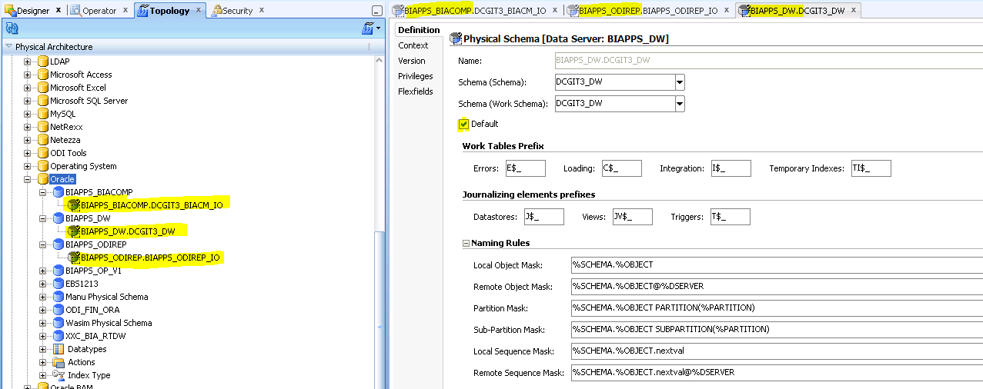

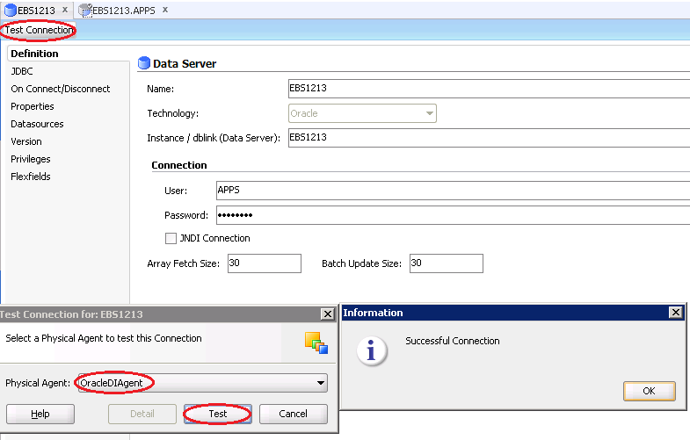

# Open and Closed Issues

1. Add open issues that you identify while writing or reviewing this document to the open issues section. As you resolve issues, move them to the closed issues section and keep the issue ID the same. Include an explanation of the resolution.  
     
   When this work product is complete, any open issues should be transferred to the project- or process-level Issue Log (Manage focus area) and managed using a project level Issue Form (Manage focus area). In addition, the open items should remain in the open issues section of this work product, but flagged in the resolution column as being transferred.

## Open Issues

| ID | Issue | Resolution | Responsibility | Target Date | Impact Date |
| --- | --- | --- | --- | --- | --- |
|  |  |  |  |  |  |
|  |  |  |  |  |  |
|  |  |  |  |  |  |
|  |  |  |  |  |  |

## Closed Issues

| ID | Issue | Resolution | Responsibility | Target Date | Impact Date |
| --- | --- | --- | --- | --- | --- |
|  |  |  |  |  |  |
|  |  |  |  |  |  |
|  |  |  |  |  |  |
|  |  |  |  |  |  |